**I - CLASS**

***Interactive Classroom Live Streaming System***

Revolutionizing the Education System in INDIA...

SECTION 1

Account Management

**Creating An Account**

If there is no account present in the tab then you will be, by default, redirected to the 'Create Account' page. Otherwise, you can also click on the ‘Add Account’ icon on the 'Login' page to go to the 'Create Account' page.

Add account

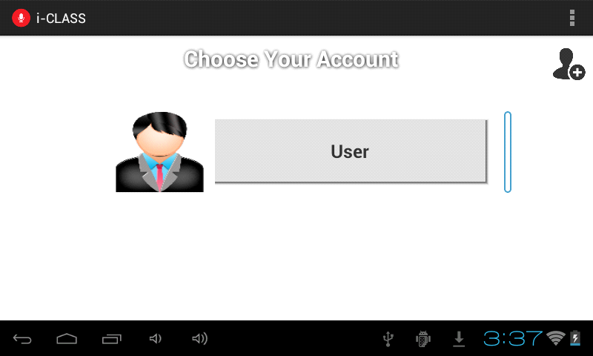

The 'Create Account' Page has the following fields:-

* Name
* Roll Number
* Date Of Birth
* Password

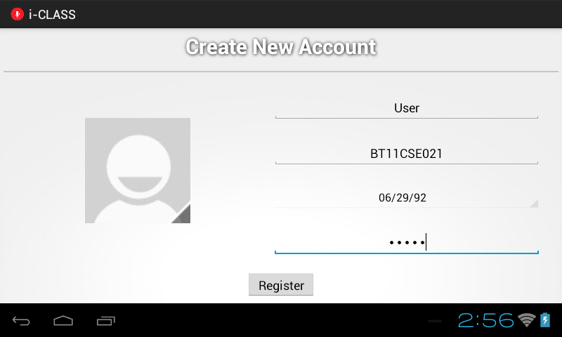

Click on the profile picture icon to select one.

Once you click on it, you will be presented with options as follows:-

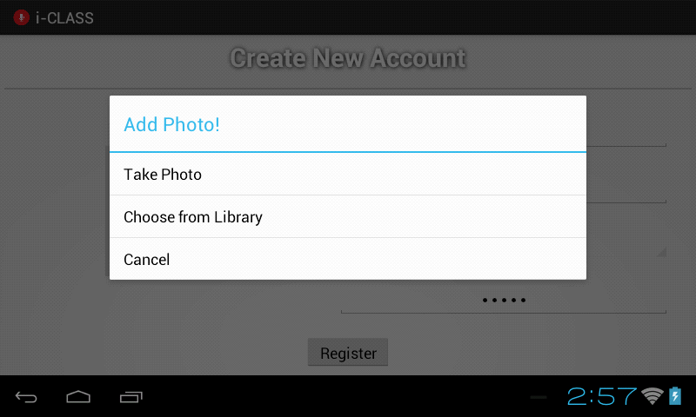

You can directly take the photo using camera of tablet or choose one from gallery if the lighting conditions are not good.

Once you select your photo the page will look like this:-

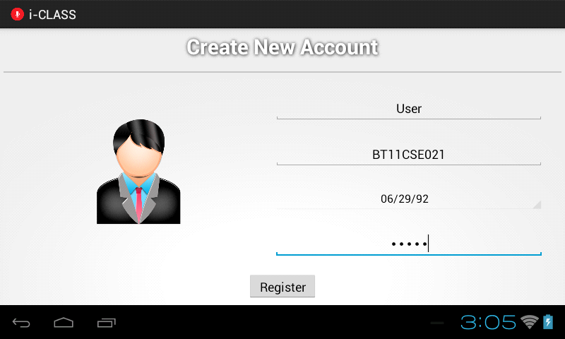

Now click on the 'Register' button to create your account.

Congratulations!!! You have just successfully created your first account.

**Changing Password of an Existing Account**

What if you forgot your password?

What if any of your friends get to know about your current password?

Don't worry. Here we are with an easy solution for you.

Forgot Password

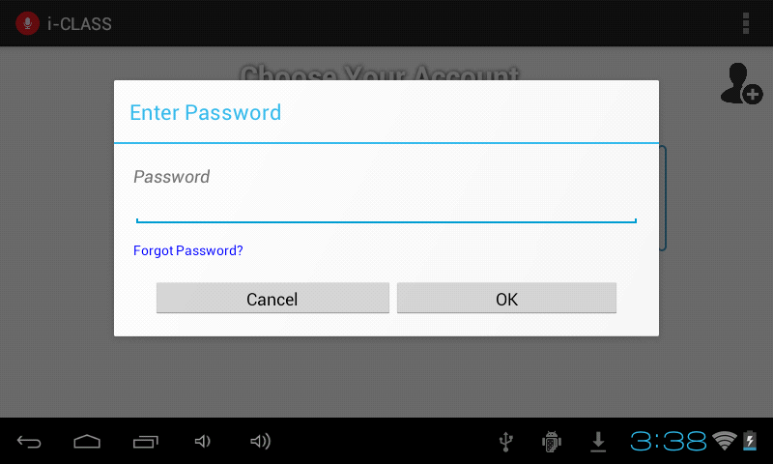

To change the password of an existing account just click on the account. You will see following Dialog Box.

Simply click on 'Forgot Password' link.

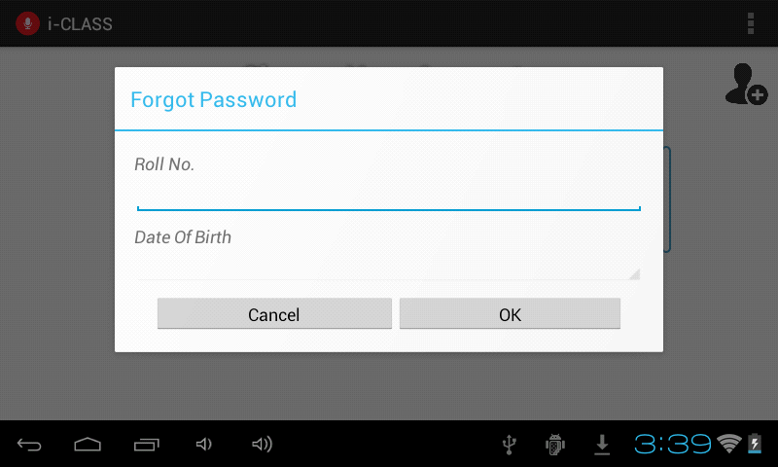

Enter the Roll Number and Date of Birth provided during the time of creation of account for verification.

Once you enter the correct credentials, you will get a dialog box to enter a new password.

SECTION 2

Establishing Connection

**Connecting with the local server (Lecturer's computer)**

The user has to connect to the local server in order to send his doubts (Audio and text) to the professor.

He does so by filling in the IP Address field and the session id field of the below shown activity screen.

Then click on the connect button.

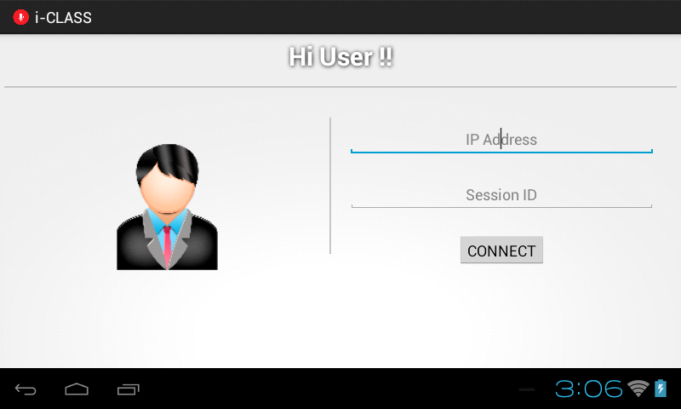

If the connection is successful, then a message will appear on the screen showing that the user's device is successfully connected to the server.

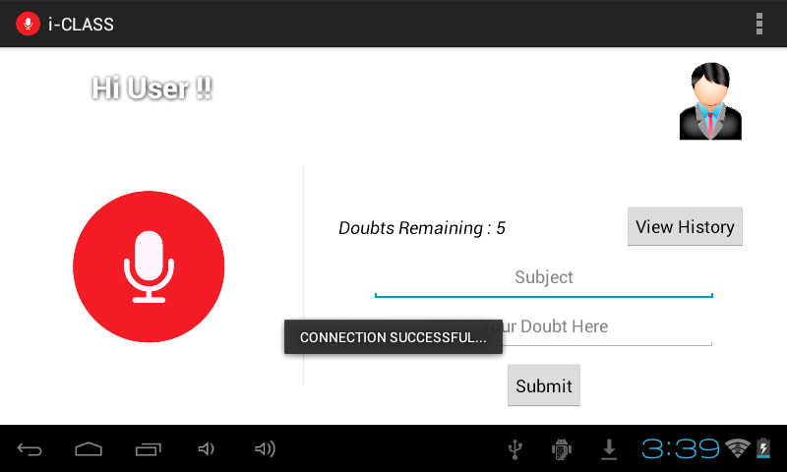

After successful connection with the server, the user is brought to the main screen of the application.

Here the user has got two choices, either he/she can go for a text doubt , or can press the microphone icon in the left, in order to ask a question live through audio streaming.

Request Audio Doubt Settings

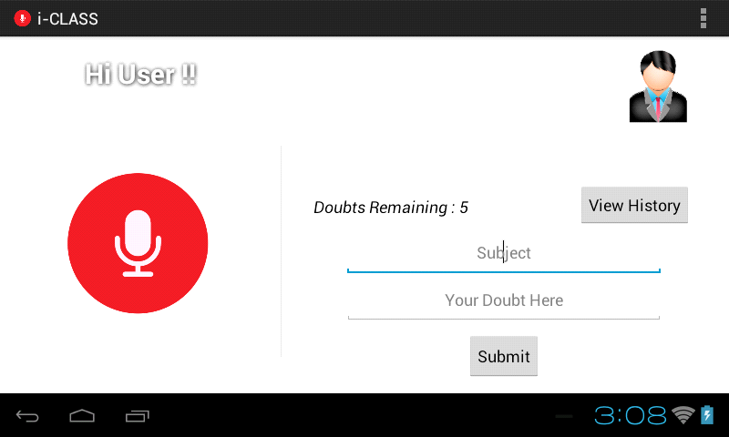

Send Text Doubt Check sent text doubts

The Main Activity

SECTION 3

Sending

Text Doubt

**Sending a Text Doubt**

In order to send a doubt in the text form, the user has to first fill in the topic (subject) of the doubt and then the main doubt in the next field.

After filling in both the fields, click the ‘Submit’ button to send the text message.

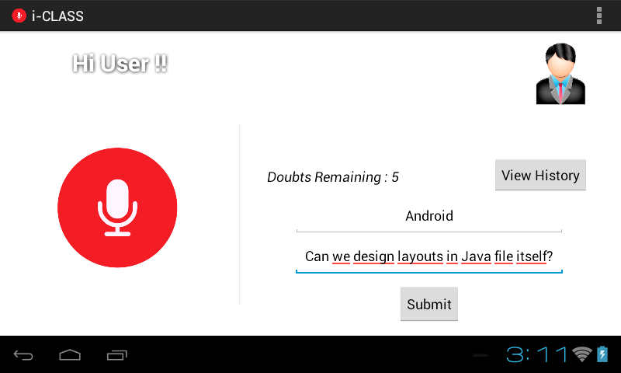

A confirmation dialog box will appear to the user regarding whether he/she really wants to send the doubt as shown below...

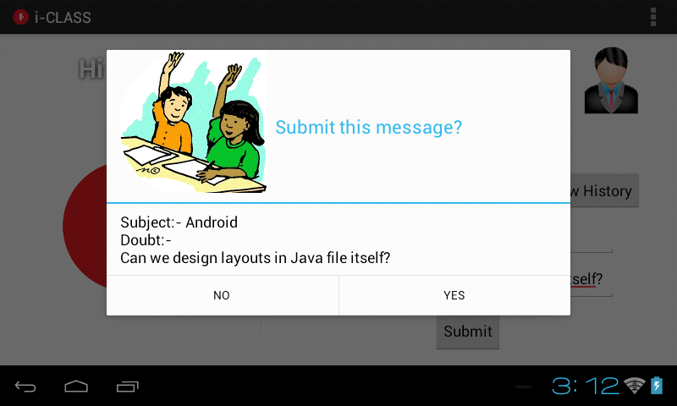

After confirmation, the text doubt will go into the waiting queue in the Lecturer's server.

Depending on the state of the lecturer in the Server's side, the professor may or may not reply to the text doubt. It is totally on the lecturer whether to accept a doubt waiting in a queue or to simply reject it.

All the text doubts which a user has asked can be seen by clicking the view history tab as shown below:-

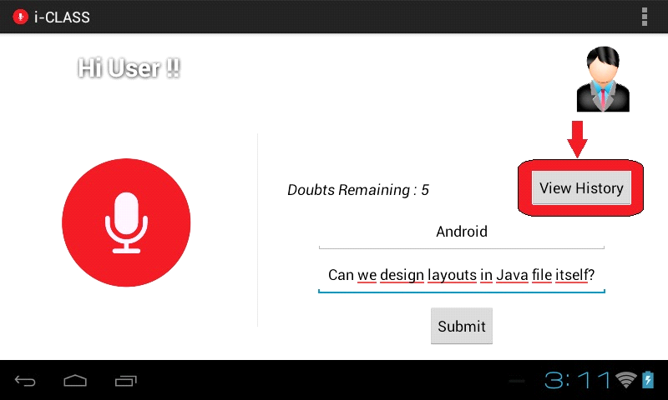

After clicking on the view history the following screen will appear.

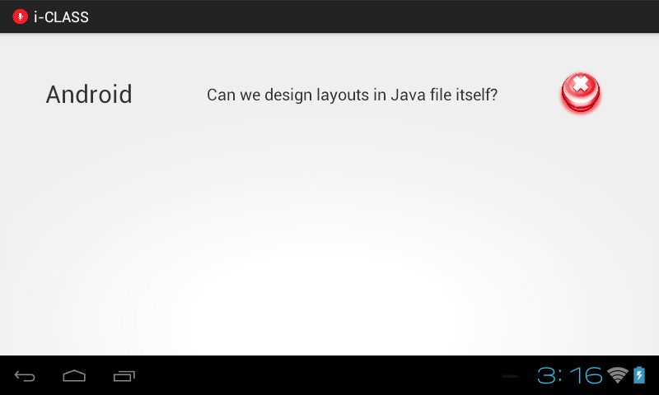

The user can click on the cross as shown above in order to cancel the text doubt.

It will be removed from the server's list also.

Note: All the text doubts which were asked in a particular server session are being maintained in a forum where anyone can view the questions anytime. The Lecturer or any assistant of him can answer those questions which were not answered in the classroom in this forum.

SECTION 4

Sending

Audio Doubt

**ASKING AN AUDIO DOUBT**

To ask an audio doubt,

1. Tap the red ‘Microphone’ icon on the main screen.

Microphone button

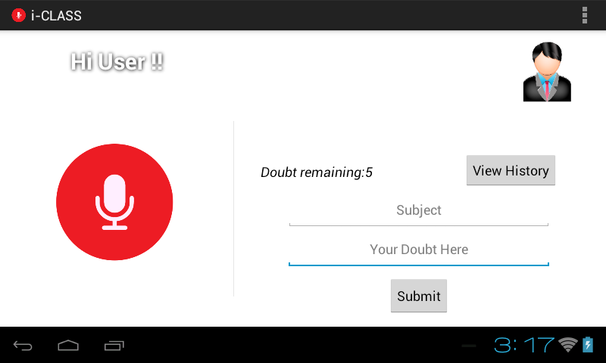

1. Now, the user has to enter the topic to provide the professor a gist of what the doubt might be about.

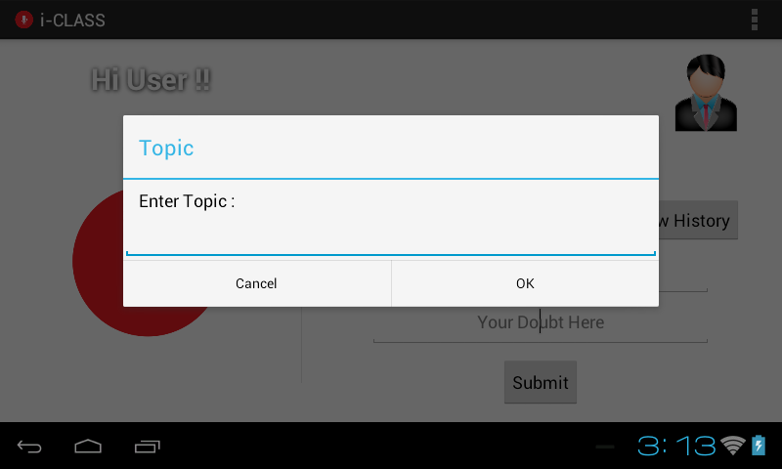

NOTE: This field is compulsory. Leaving it empty won’t allow the user to send the doubt.

1. Then, the following activity appears on the screen.

Disconnect Position in queue Ask Text Doubt



Here, your position number in the waiting queue is displayed. The waiting queue consists of all the audio requests sent to the server from various users. The professor can select any of the audio requests.

Here, the user has various options.

* 1. If he wants to discontinue at any point of time during his waiting, he can press the ‘Disconnect’ button to exit to the main screen.
  2. If he wants to ask a text doubt as well while waiting in the queue, he can press the ‘Text Doubt’ button, which on result opens the following activity.

Send text doubt

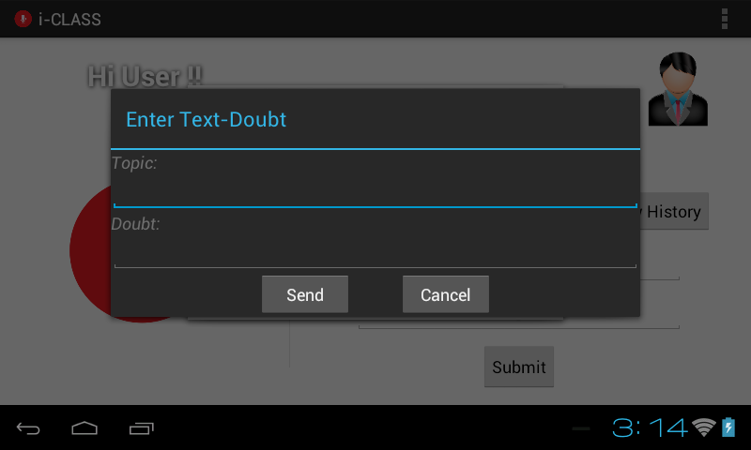

The user should enter the topic and the doubt details in the fields provided and press the ‘Send’ button to send the doubt.

* 1. If the audio doubt request is accepted by the professor, you get a ‘Start Speaking’ button on your screen, as a confirmation from the professor that your request has been accepted.

Start Speaking

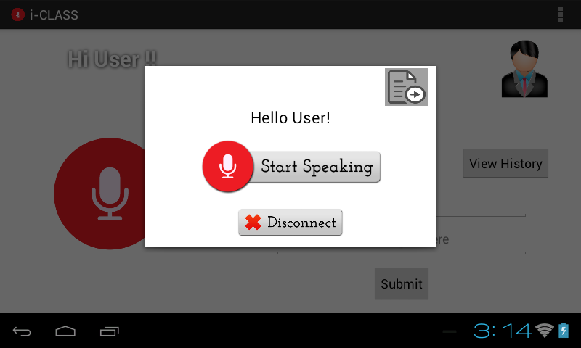

If the user presses this button, his audio streaming starts and he can continue to speak as long as he wishes.

Disconnect

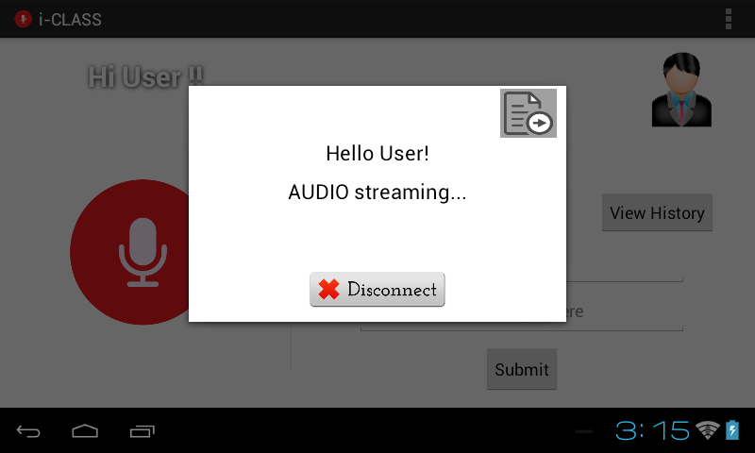

When the user wishes to stop, he can press the ‘Disconnect’ button and go back to the main screen.

* 1. If the professor rejects your request, the following dialog shows up on your screen.

